E-Portfolio of Senzo Stofile

219345406

Work I’ve done includes the following:

Design and animating with SVG – 31/05/25

The task required me to create an animation based on a given theme. As I’d chosen a boat, I decided to animate it rocking back and forth on the ocean with the sun above transitioning to the moon at night and back. I wanted to capture the feeling of travelling from one hemisphere of the world to the next.



The main challenges I faced with this task included designing the boat and converting it to an SVG file, trying to animate 3 different elements in a permanent loop cycle and figuring out how to give the boat a somewhat realistic bobbing animation. After considering many external examples I learnt how to create looped animations and figured out that having the boat just tilt from axis to axis would serve perfectly as a bobbing animation and was very satisfied with the result. Download the full animation file on my GitHub, (219345406_Senzo Stofile_SVG-Boat.rar), unzip and open index.html.

Wireframe Huawei Project Collaboration – 24/09/25

Below is wireframe work I created for both mobile and desktop view for the WIL Huawei project created on Figma. It’s a revised version of an existing site that we need to make a South African version of and thus stick to the website theme and brand of Huawei.

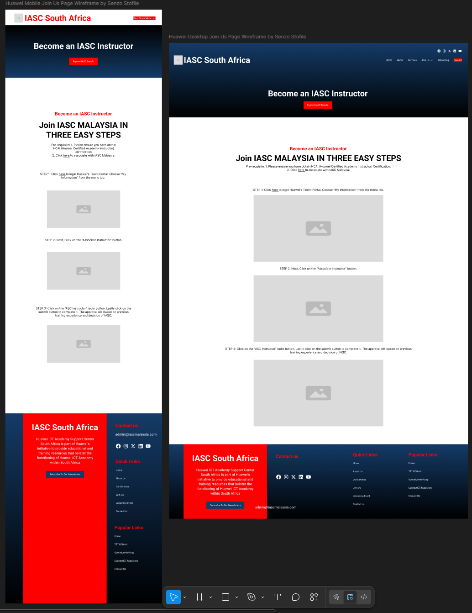

The main challenges I faced were group collaboration and ensuring all elements were consistent between the entire group’s design choices. As we all had different pages to work with that only share the same header and footers. So, ensuring that all of them were consistent in design and communicating the standard everyone should follow through online only communication methods like WhatsApp was difficult as getting everyone on the same page was challenging. By separating us into groups we were able to more effectively deliver instructions to members that were doing similar tasks to each of us and thus solve this issue of consistency in design shown below. Link to the Figma board here: https://www.figma.com/design/RcRN9jizc4sLoBpRQJKrHa/Wireframes?node-id=0-1&t=AbuuE9Z5p6rpi55I-1

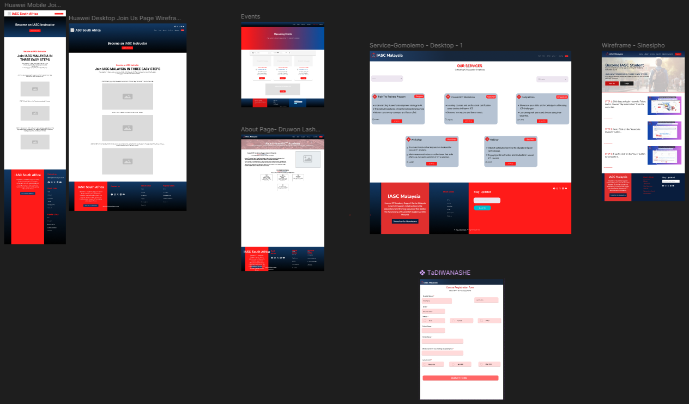

Huawei Website Join Us page – 20/10/25

Moving forward with the Huawei Wil project brings us to the creation of the website itself, specifically the Join Us page. This is the first draft of the page and still requires more refinement to be closer in visuals to the wireframe.   
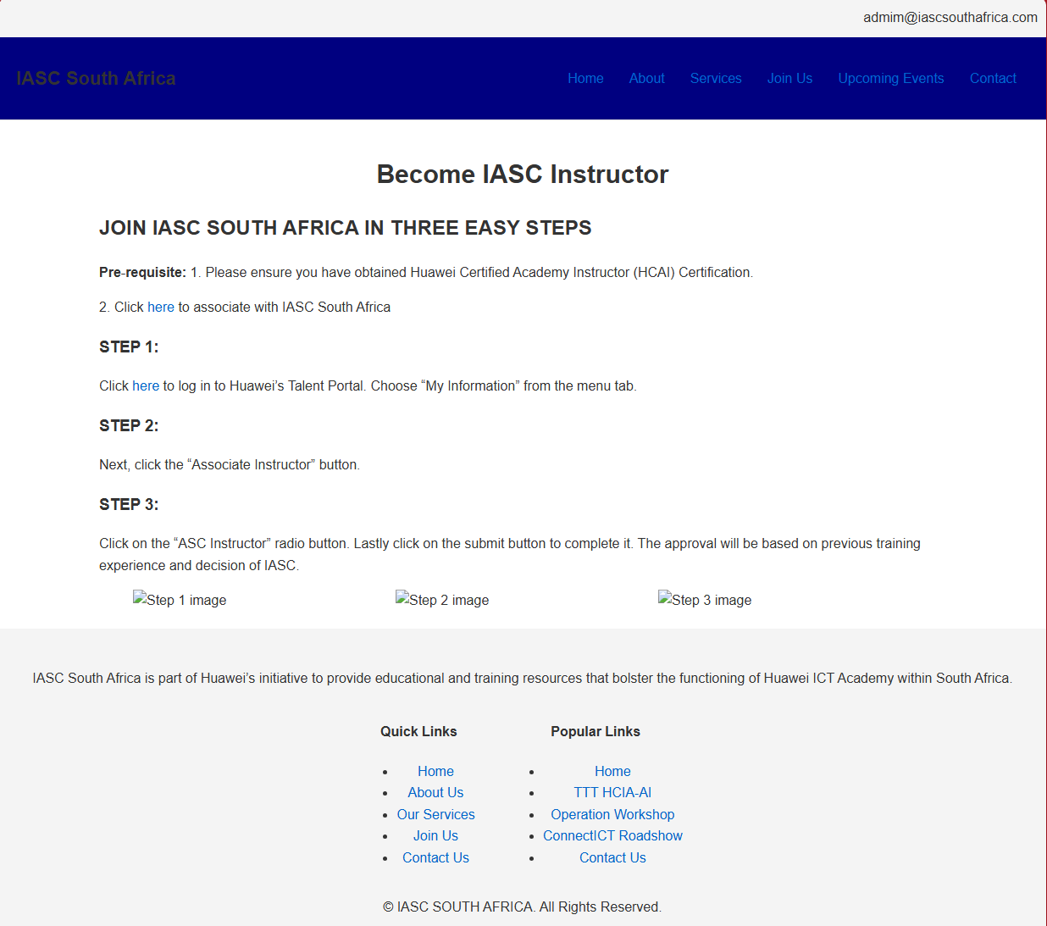

Challenges I faced were styling the navigation bar and footer bar as well as implementing the dropdowns for the navigation bar options. As this is the first revision, I will be continuing to style the page according to the brand guidelines with red and blue. Luckily if I run into any hurdles, I have group members to collaborate with to come up with solutions. To access this draft of the webpage download (Senzo Stofile Join Us Page.rar) on my GitHub, unzip and open join-us.html.